**CIVIL REPORTING SYSTEM**

**A Project Report**

Submitted in partial fulfillment of the

Requirements for the award of the degree of

**BACHELOR OF SCIENCE (INFORMATION TECHNOLOGY)**

**By**

Suraj Poojary

&

Siddharth Sharma

**Under the esteemed guidance of**

**Mr. Murugesh Chandran**



**DEPARTMENT OF INFORMATION TECHNOLOGY**

**VIVEK COLLEGE OF COMMERCE**

***(Affiliated to University of Mumbai)***

**MUMBAI-MAHARASHTRA-400104**

**Abstract**

Civil Reporting System is a project that is designed to facilitate the citizens and the Municipal Authorities to simplify the process of complaint filing and management. It consists of a mobile application for the citizens as well as a ASP.NET web application for the Authorities. The citizens can file complaints through the app and the authorities will get those complaints and assign them to the appropriate officer.

The officer will then solve the complaint and notify the administrator through the system, the administrator will then change the status of the complaint. The user can track all of this through their mobile app from their dedicated section to view the complaint status

This system is a significant improvement over the existing system of complaint filing and management, and hence we believe that our project can make a significant contribution to the modernization of the governance procedures.

**ACKNOWLEDGEMENT**

We would like to place our sincere gratitude to everyone who has contributed to the successful completion of this project directly or indirectly.

We wish to thank the Principal of our college, **Dr.** **Vijeta Shetty** and our respected professors, **Prof.** **Aparna S. Padte**, **Prof.** **Anupama S. Bali**, **Prof.** **Maia Muthukumar** and **Prof.** **Murgesh Chandran**, as well as the Management and the Library Staff for their great support throughout our graduation years.

We take this opportunity to specially thank our project guide, **Prof. Murugesh Chandran**, without his guidance & critical appreciation, this project would have been incomplete. Right from its inception, this project has been shaped by his expert opinions and he has helped us improve our project in all manners and achieve the level that it has acquired.

Also, we wish to extend our heartfelt gratitude to our lab assistant, **Mr. Neeraj Tiwari**, for having helped us a lot during our brainstorming sessions and particularly for the permission to use the computer labs whenever we needed to.

Thanking You,

**SURAJ POOJARY**

&

**SIDDHARTH SHARMA**

**DECLARATION**

I hereby declare that the project entitled, **“Civil Reporting System”** done at **Vivek College of Commerce**, has not been in any case duplicated to submit to any other university for the award of any degree. To the best of my knowledge other than me, no one has submitted to any other university.

The project is done in partial fulfillment of the requirements for the award of degree of **BACHELOR OF SCIENCE (INFORMATION TECHNOLOGY)** to be submitted as final semester project as part of our curriculum.

**SURAJ POOJARY SIDDHARTH SHARMA**

**TABLE OF CONTENTS**

**Chapter 1: Introduction**

**1.1 Background**

**1.2 Objectives**

**1.3 Purpose and Scope**

1.2.1 Purpose

1.2.2 Scope

1.2.3 Applicability

**1.4 Organization of Report**

**Chapter 2: System Analysis**

**2.1 Existing System**

**2.2 Proposed System**

**2.3 Requirement Analysis**

2.3.1 Problem Definition

2.3.2 Issues

2.3.3 Requirement Specification

**2.4 Technical Requirements for development**

**2.5 Justification of selection of Technology**

**Chapter 3: System Design**

**3.1 Module Division**

**3.2 Data Dictionary**

**3.3 ER Diagrams**

**3.4 UML Diagrams**

**CHAPTER 1**

**INTRODUCTION**

Civil Reporting System is a tool designed to function as a platform for the citizens to communicate with the Municipal corporation authorities and replace the old method of writing letters and e-mails as they are a time consuming mode of communicating with the authorities.

* 1. **Background**

In this age of rapid urban development and internet connectivity, the gap in communication between the residents of a city and the Municipal Corporation that runs the city should be reduced to a bare minimum.

Unfortunately, there hasn’t been much progress in that area or it has been very slow because this topic hasn’t been seen as a priority by the authorities even with all the technological advancements, due to which the citizens have suffered as they are yet to see a channel of communication that is as fast and as up-to-date as the technology of today.

* 1. **Objectives**

The objective of our project is to provide solutions to both – the citizens and the municipal corporation. We aim to provide the citizens with a platform, which they can use to communicate with the authorities.

Another objective of the project is to provide the municipal corporation with a tool – which they previously didn’t have - to manage all the complaints that they receive, freeing them from the responsibility of managing all the heaps of files that are present in their office.

The most important of all the objectives is to save time of the Municipal authorities so that they can focus on multiple tasks in a single day and utilize their time in a more efficient manner. Other secondary objectives include, creating awareness among the masses about digitization of the traditional paper based administration – which is regarded as time consuming - as we are moving towards the idea of a Digital India

* 1. **Purpose, Scope and Applicability**

The following are the purpose, scope and applicability of the civil reporting system that we are going to develop.

* + 1. **Purpose**

The project has been undertaken by us to simplify the communication process between the authorities and the citizens by removing the unnecessary and time consuming formalities that are in place right now, and to put in its place a new system that uses an entirely new channel of communication – the Internet and the mobile phone.

Since the citizens can directly communicate with the authorities, it saves a lot of their time as they don’t have to follow a certain protocol anymore, the authorities will forward their query or complaint to the appropriate officer in charge and make the whole process hassle free for them.

This way the authorities also don’t have to deal with all of the extra paperwork like forms and letters resulting from the old method of registering a complaint, all they have to do is to forward any complaint that they receive to the appropriate officer and that officer will take the necessary steps needed to solve that particular complaint.

**1.3.2 Scope**

The scope of our system ranges from the citizens that will use the system to report their grievances, to the Municipal authorities that will use the system to then manage those complaints and solve them.

This offers us multiple avenues where we can simplify the process of complaint filing and complaint management for both the parties involved respectively.

Citizens can have various problems, like waste disposal, water supply, sewage and drainage problems and waterlogging etc., through the mobile application they can just simply click a picture and post a complaint, which will then be forwarded to the concerned officer. Thus we are building a single platform that can be used to resolve a wide range of issues pertaining to most of the departments in the Municipal Corporation.

Thus we can say that our project is not just one dimensional in terms of its scope and we have tried to cover as many areas as we could, and we have also tried to make our project scalable so that we can build upon the existing architecture instead of building a new system entirely from scratch.

**1.3.2 Applicability**

The citizens here can file their complaints in a matter of few clicks instead of making a personal visit to the local Municipal Corporation office due to which the transportation time and cost of the citizen is saved and the paper work is also reduced making the whole operation an environment friendly one.

The Mobile app can also help people with certain physical disabilities to file complaints without having to worry about travelling all the way to the Municipality office and properly handling the paperwork or documentation and going from table to table, to find the right officer to submit their complaint since the app can do both the things for them, so that they don’t have to take all the trouble by themselves.

Municipal officers that have been assigned a complaint through the system will need to provide a proof-of-work that they have solved that particular issue and not just click solved on the screen and think that their job is finished, in this way we are promoting accountability of the officers towards the citizen.

**1.4 Organization of the Report**

After going through with the introduction to the project, we will now summarize the remaining chapters of the project report.

**Survey of Technology:** In this chapter we will be looking into the technology which will be used to implement the project. What other technologies will we be introducing in the project and what different features will be provided by the project, are the questions that would be answered here

**Requirement and Analysis:** This chapter followsthe detail analysis of requirements by the user for the project. Collecting all the data and preparing a document to get a clear cut view of the ideas that will be implemented in the project. All the requirements i.e. software and hardware feasibility study will be carried out here.

**System Design:** This chapter gives the idea of the overall design of the project through diagrams. Also the information of flow of the data and the validations are included.

**CHAPTER 2**

**SYSTEM ANALYSIS**

**2.1 Existing System**

Till now most of the complaints are filed physically or via emails, which in the case of emails require multiple email id’s too, for the relevant authority of a particular department. This might take a lot of time and effort for finding the authority first, for a particular kind of complaint and then finding an email ID of the department.

Due to these multiple channels of communication, the authorities also find it difficult to track each and every complaint since the users might file their complaint through the medium of their choice, this leads to confusion among the authorities as there is no central system which manages all of the complaints in a single place.

**2.2 Proposed System**

Through our system. complaints can be easily registered by the user and can be tracked with a unique complaint ID. Both the admin/authority is restricted to edit or delete the complaint. The authority can only update the progress status of the raised complaint. The user can then view the progress of the complaint.

This system will not only save the time of the complaint filers but also allow them to track their complaint and its status through regular intervals of time. Once the complaint is solved, the user gets the update on their phone.

**2.3 Requirement Analysis**

**2.3.1 Problem Definition**

Nowadays it is important that if a user is using a mobile app, they have to be provided with accurate information/guidance and proper security of their data should be implemented, to create trustworthiness between the citizens and the government. Authentication and verification of users has also become mandatory now.

**2.3.2 Issues**

Some of the issues that the citizens face with the current system are as follows

* **Time Consumption:** Travelling to the office of the Municipal Authorities and filing the complaint physically is a time consuming process as it involves hopping from table to table.
* **Dealing with Paperwork:** Another problem with the physical method is that involves dealing with a lot of paperwork. The citizens have to fill various forms to file even a single complaint.
* **Lack of accountability:** Municipal officers in the past have been accused of not being accountable towards the citizens, through our project we are promoting accountability among the Municipality officers.

**2.3.3 Requirements specification**

Here we are going to develop a system which acts as a communication channel in between the citizens of a locality and the Municipal Corporation of that locality the main objective is to provide a common interface to the citizens and the authorities so that they can communicate trustfully, at ease and without any inconvenience for both the parties involved.

**Overview**

* The user can file a complaint by logging in to the app
* The user will be requested to create and register an account by filling out all the details that are required
* A complaint ID will be generated when the user files a complaint it will be unique for every complaint the user files
* The user can track status of all their filed complaints through a separate tab called ‘complaint status’.
* The administrator will be able to delegate various complaints to an officer under him.
* The officer can change the status of the complaint assigned to him once he has solved the complaint

**2.4 Technical Requirements for Development**

**Hardware Requirements**

|  |  |
| --- | --- |
| Hard Disk Space | 50 GB or more |
| CPU | Intel i3 3rd Generation/AMD A4 APU or later |
| Graphics Card | Intel integrated graphics/AMD Radeon graphics (recommended) |
| RAM | 2 GB or more (DDR3/DDR4) |
| Internet Connection | Ethernet, Wi-Fi, Mobile data |

**Software Requirements**

|  |  |
| --- | --- |
| Front end | Microsoft Visual Studio 2015  Android Studio |
| Back end | MySQL |
| Language | C#, Java |
| Documentation Tool | Microsoft Word 2015  Star UML |

**Technical feasibility for user side: -**

**Hardware requirements:**

Any Cellular Phone that supports Internet, via Wi-Fi or cellular data connection (4G preferred). Latest hardware specification would be the best to view the mobile application with enhanced graphics.

**Software requirements:**

The latest version of android operating system is preferable (Android 5.0 lollipop or higher) and Microsoft Windows 10’s latest stable release

**2.5 Justification of Selection of technology**

**Microsoft Visual Studio**

Microsoft Visual Studio is an integrated development environment (IDE) from Microsoft. It is used to develop computer programs, as well as websites, web apps, web services and mobile apps. Visual Studio uses Microsoft software development platforms such as Windows API, Windows Forms, Windows Presentation Foundation, Windows Store and Microsoft Silverlight. It can produce both native code and managed code.

Visual Studio includes a code editor supporting IntelliSense (the code completion component) as well as code refactoring. The integrated debugger works both as a source-level debugger and a machine-level debugger. Other built-in tools include a code profiler, forms designer for building GUI applications, web designer, class designer, and database schema designer. It accepts plug-ins that enhance the functionality at almost every level—including adding support for source control systems (like Subversion and Git) and adding new toolsets like editors and visual designers for domain-specific languages or toolsets for other aspects of the software development lifecycle (like the Team Foundation Server client: Team Explorer).

Visual Studio supports 36 different programming languages and allows the code editor and debugger to support (to varying degrees) nearly any programming language, provided a language-specific service exists. Built-in languages include C, C++, C++/CLI, Visual Basic .NET, C#, F#, JavaScript, TypeScript, XML, XSLT, HTML, and CSS. Support for other languages such as Python, Ruby, Node.js, and M among others is available via plug-ins. Java (and J#) were supported in the past.

**Android Studio**

Android Studio is the official integrated development environment (IDE) for Google's Android operating system, built on JetBrains' IntelliJ IDEA software and designed specifically for Android development. It is available for download on Windows, MacOS and Linux based operating systems. It is a replacement for the Eclipse Android Development Tools (ADT) as the primary IDE for native Android application development.

**The following features are provided in the current stable version:**

* Gradle-based build support
* Android-specific refactoring and quick fixes
* Lint tools to catch performance, usability, version compatibility and other problems
* ProGuard integration and app-signing capabilities
* Template-based wizards to create common Android designs and components
* A rich layout editor that allows users to drag-and-drop UI components, option to preview layouts on multiple screen configurations
* Support for building Android Wear apps
* Built-in support for Google Cloud Platform, enabling integration with Firebase Cloud Messaging (Earlier 'Google Cloud Messaging') and Google App Engine
* Android Virtual Device (Emulator) to run and debug apps in the Android studio.

Android Studio supports all the same programming languages of IntelliJ (and CLion) e.g. Java, C++, and more with extensions, such as Go; and Android Studio 3.0 or later supports Kotlin and all Java 7 language features and a subset of Java 8 language features that vary by platform version. External projects backport some Java 9 features. While IntelliJ that Android Studio is built on supports all released Java versions, and Java 12, it's not clear to what level Android Studio supports Java versions up to Java 12 (the documentation mentions partial Java 8 support). At least some new language features up to Java 12 are usable in Android.

**MySQL**

MySQL is written in C and C++. Its SQL parser is written in yacc, but it uses a home-brewed lexical analyzer. MySQL works on many system platforms, including AIX, BSDi, FreeBSD, HP-UX, eComStation, i5/OS, IRIX, Linux, macOS, Microsoft Windows, NetBSD, Novell NetWare, OpenBSD, OpenSolaris, OS/2 Warp, QNX, Oracle Solaris, Symbian, SunOS, SCO OpenServer, SCO UnixWare, Sanos and Tru64. A port of MySQL to OpenVMS also exists.

The MySQL server software itself and the client libraries use dual-licensing distribution. They are offered under GPL version 2, or a proprietary license.

Support can be obtained from the official manual. Free support additionally is available in different IRC channels and forums. Oracle offers paid support via its MySQL Enterprise products. They differ in the scope of services and in price. Additionally, a number of third party organizations exist to provide support and services, including MariaDB and Percona.

Major features as available in MySQL 5.6:

* A broad subset of ANSI SQL 99, as well as extensions
* Cross-platform support
* Stored procedures, using a procedural language that closely adheres to SQL/PSM
* Triggers
* Cursors
* Updatable views
* Online Data Definition Language (DDL) when using the InnoDB Storage Engine.
* Information schema
* Performance Schema that collects and aggregates statistics about server execution and query performance for monitoring purposes.
* A set of SQL Mode options to control runtime behavior, including a strict mode to better adhere to SQL standards.
* X/Open XA distributed transaction processing (DTP) support; two phase commit as part of this, using the default InnoDB storage engine
* Transactions with savepoints when using the default InnoDB Storage Engine. The NDB Cluster Storage Engine also supports transactions.
* ACID compliance when using InnoDB and NDB Cluster Storage Engines
* SSL support
* Query caching
* Sub-SELECTs (i.e. nested SELECTs)
* Built-in replication support
* Asynchronous replication: master-slave from one master to many slaves or many masters to one slave
* Semi synchronous replication: Master to slave replication where the master waits on replication
* Synchronous replication: Multi-master replication is provided in MySQL Cluster.
* Virtual Synchronous: Self-managed groups of MySQL servers with multi master support can be done using: Galera Cluster [84] or the built in Group Replication plugin.
* Full-text indexing and searching.
* Embedded database library
* Unicode support.
* Partitioned tables with pruning of partitions in optimizer
* Shared-nothing clustering through MySQL Cluster
* Multiple storage engines, allowing one to choose the one that is most effective for each table in the application.
* Native storage engines InnoDB, MyISAM, Merge, Memory (heap), Federated, Archive, CSV, Blackhole, NDB Cluster.
* Commit grouping, gathering multiple transactions from multiple connections together to increase the number of commits per second

**C#**

C# is a general-purpose, multi-paradigm programming language encompassing strong typing, lexically scoped, imperative, declarative, functional, generic, object-oriented (class-based), and component-oriented programming disciplines. It was developed around 2000 by Microsoft as part of its .NET initiative, and later approved as an international standard by Ecma (ECMA-334) and ISO (ISO/IEC 23270:2018). Mono is the name of the free and open-source project to develop a compiler and runtime for the language. C# is one of the programming languages designed for the Common Language Infrastructure (CLI).\

C# was designed by Anders Hejlsberg, and its development team is currently led by Mads Torgersen. The most recent version is 8.0, which was released in 2019 alongside Visual Studio 2019 version 16.3.

The ECMA standard lists these design goals for C#:

* The language is intended to be a simple, modern, general-purpose, object-oriented programming language.
* The language, and implementations thereof, should provide support for software engineering principles such as strong type checking, array bounds checking, detection of attempts to use uninitialized variables, and automatic garbage collection. Software robustness, durability, and programmer productivity are important.
* The language is intended for use in developing software components suitable for deployment in distributed environments.
* Portability is very important for source code and programmers, especially those already familiar with C and C++.
* Support for internationalization is very important.
* C# is intended to be suitable for writing applications for both hosted and embedded systems, ranging from the very large that use sophisticated operating systems, down to the very small having dedicated functions.
* Although C# applications are intended to be economical with regard to memory and processing power requirements, the language was not intended to compete directly on performance and size with C or assembly language.

**Java**

Java is a general-purpose programming language that is class-based, object-oriented, and designed to have as few implementation dependencies as possible. It is intended to let application developers write once, run anywhere (WORA), meaning that compiled Java code can run on all platforms that support Java without the need for recompilation. Java applications are typically compiled to bytecode that can run on any Java virtual machine (JVM) regardless of the underlying computer architecture. The syntax of Java is similar to C and C++, but it has fewer low-level facilities than either of them. As of 2019, Java was one of the most popular programming languages in use according to GitHub, particularly for client-server web applications, with a reported 9 million developers.

Sun has defined and supports four editions of Java targeting different application environments and segmented many of its APIs so that they belong to one of the platforms. The platforms are:

* Java Card for smart-cards.
* Java Platform, Micro Edition (Java ME) – targeting environments with limited resources.
* Java Platform, Standard Edition (Java SE) – targeting workstation environments.
* Java Platform, Enterprise Edition (Java EE) – targeting large distributed enterprise

The classes in the Java APIs are organized into separate groups called packages. Each package contains a set of related interfaces, classes, and exceptions. Refer to the separate platforms for a description of the packages available.

**CHAPTER 3**

**System Design**

**3.1 Module Division**

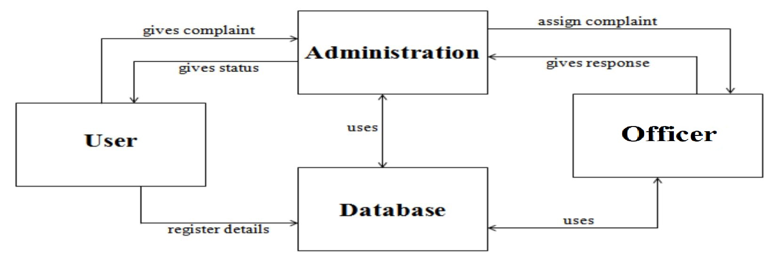

**MODULES:** The given are the modules for Civil Reporting System Project:

1. **ADMINISTRATION MODULE:** This module has control over the whole system. This module will contain all the access and it has the authority to visit even user profiles and accounts, also this module will delegate the complaints filed by the user to the different officers, and also maintains the database of the users as well as the complaints filed by the users.
2. **USER MODULE:** This module works for the users who wish to fill some kind of complaint they have. Account is to be created by the user in this module. The user has to use the unique username and password that they have created to log in into the mobile application.
3. **OFFICER MODULE:** This module contains all the different Officers or heads from the Municipal authority’s departments who can also visit queries solve them, they don’t have any permission to edit or delete the complaint’s status.
4. **DATABASE MODULE:** This module is being maintained by the administration itself but is a separate module because it contains all the data and information gathered up to the time, for further assessment and all the updating and deletion is being done in this module itself.

**3.2 ER DIAGRAM**

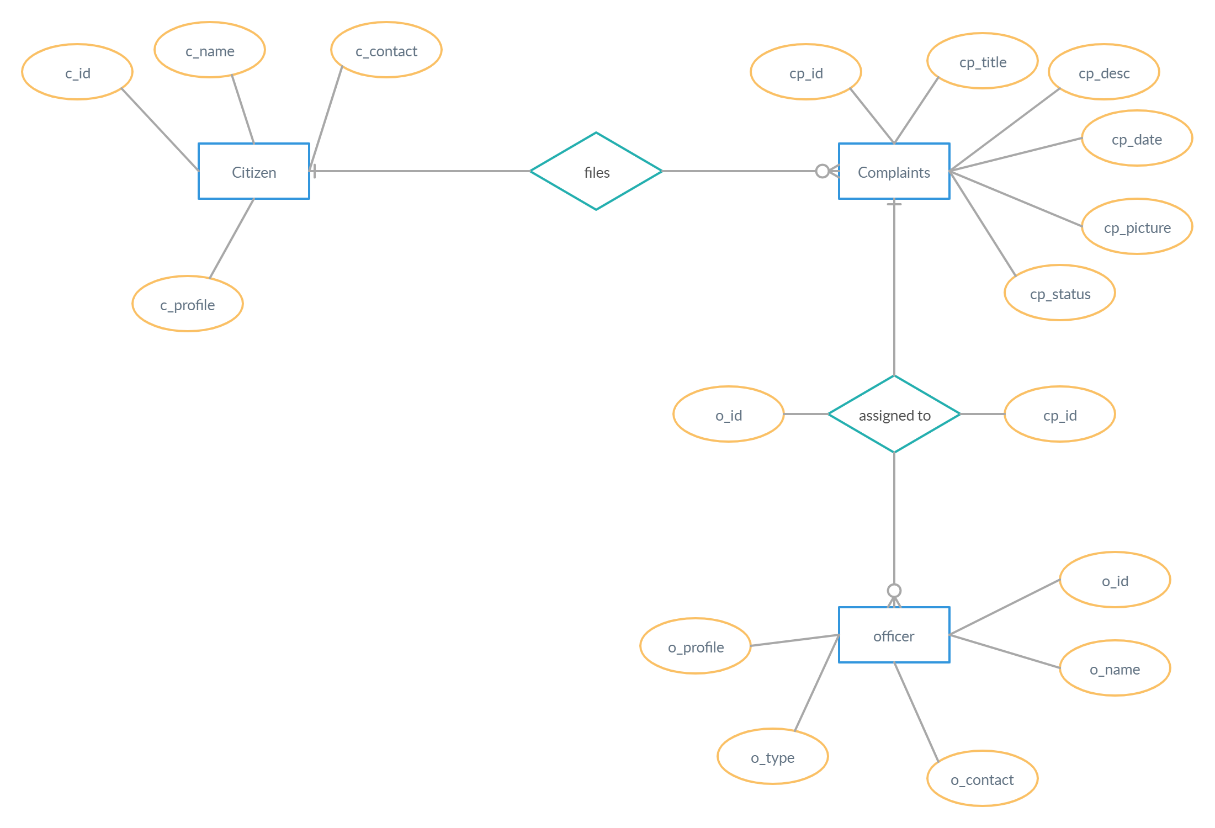

**3.3 Data Dictionary**

**Citizen Table**

|  |  |  |  |
| --- | --- | --- | --- |
| **Sr. No** | **Attribute** | **Datatype** | **Constraints** |
| 1 | c_id | vachar(20) | PRIMARY KEY, NOT NULL |
| 2 | c_name | varchar(20) | NOT NULL |
| 3 | c_contact | int(12) | NOT NULL |
| 4 | c_profile | varbinary(max) | NOT NULL |

**Complaints Table**

|  |  |  |  |
| --- | --- | --- | --- |
| **Sr. No** | **Attribute** | **Datatype** | **Constraints** |
| 1 | cp_id | vachar(10) | PRIMARY KEY, NOT NULL |
| 2 | cp_title | vachar(40) | NOT NULL |
| 3 | cp_location | vachar(100) | NOT NULL |
| 4 | cp_desc | vachar(1000) | NOT NULL |
| 5 | cp_date | Date | NOT NULL |
| 6 | cp_status | varchar(50) | NOT NULL |
| 7 | cp_picture | varbinary(max) | NOT NULL |

**Officer Table**

|  |  |  |  |
| --- | --- | --- | --- |
| **Sr. No** | **Attribute** | **Datatype** | **Constraints** |
| 1 | o_id | varchar(10) | PRIMARY KEY, NOT NULL |
| 2 | o_name | varchar(20) | NOT NULL |
| 3 | o_contact | int(20) | NOT NULL |
| 4 | o_profile | varbinary(max) | NOT NULL |
| 5 | o_type | varchar(20) | NOT NULL |

**Assigned table**

|  |  |  |  |
| --- | --- | --- | --- |
| **Sr. No** | **Attribute** | **Datatype** | **Constraints** |
| 1 | o_id | vachar(10) | FOREIGN KEY |
| 2 | cp_id | vachar(10) | FOREIGN KEY |

**Use Case Diagram**

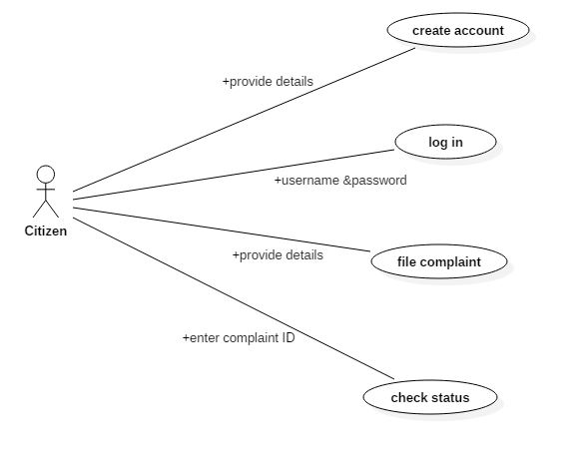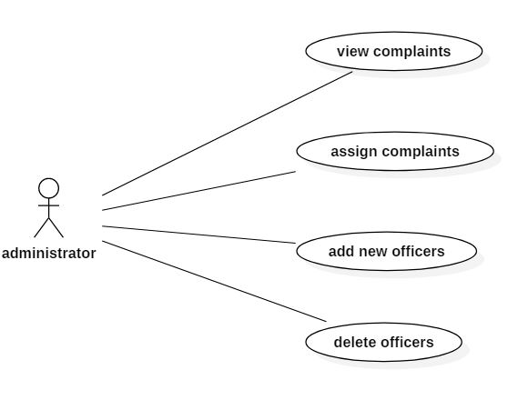

Citizen

Administrator

**Gantt Chart**

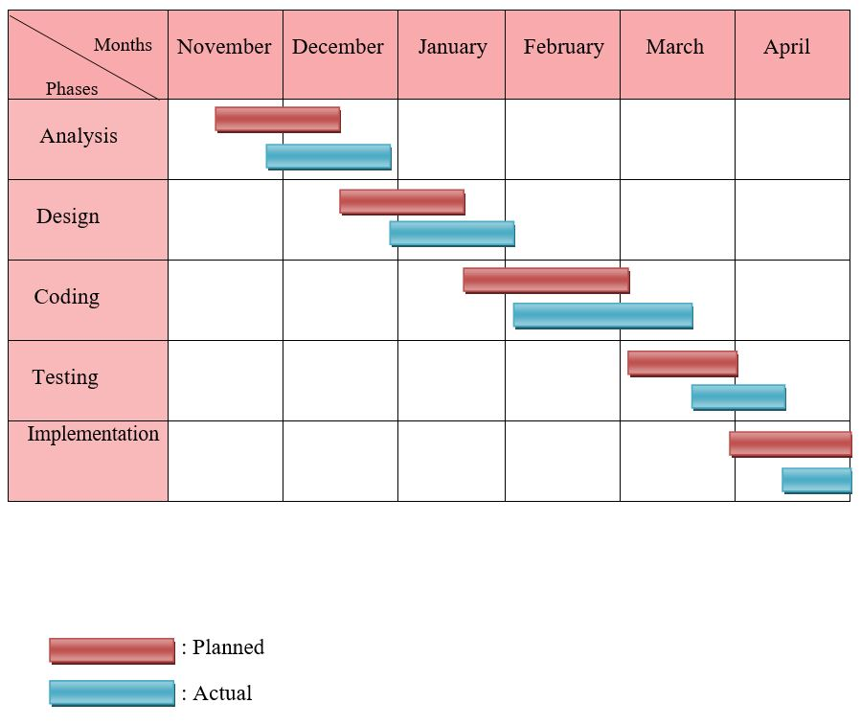

**Data Flow Diagram**

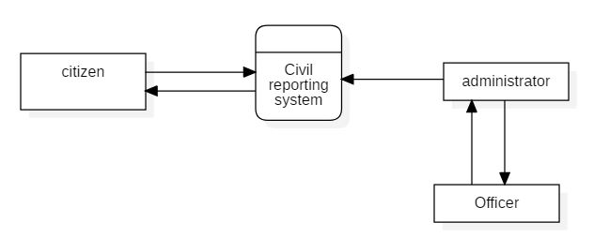

**Sequence Diagram**

